**Challenge**

Erwan Majid /2341720064

Febrian Arka Samudra / 23417200066

M Rizal Al Baihaqi / 2341720225

Xavier Zaidane Athaya /2341720189

1.Make auto increment in ID participant

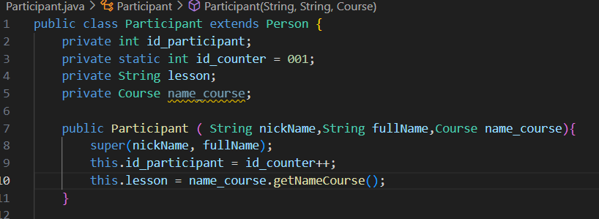

-Then if we need to print like 001 002,we must print with format:



-and in the main:



-output:

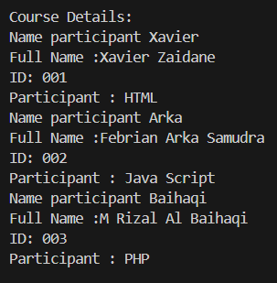

2.make course can choose

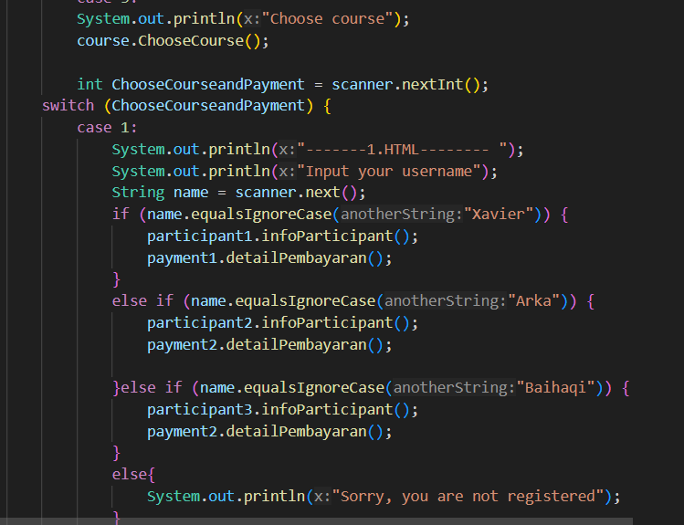

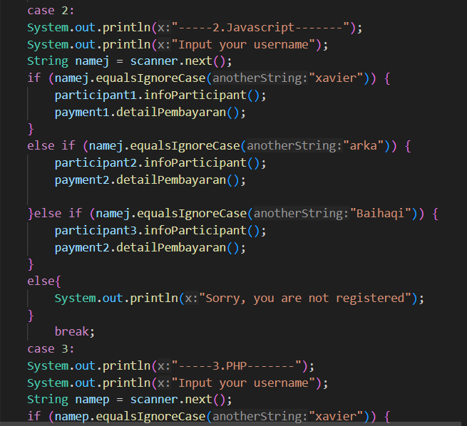

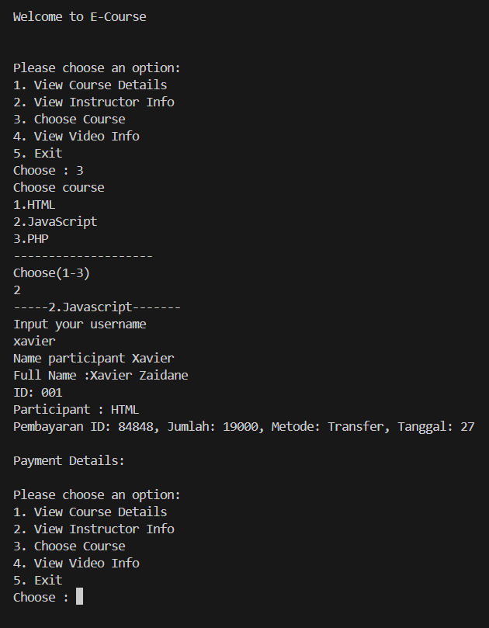Output: